Compiler Mini Project.

**Aim:** Design a predictive parser for a given language

**Code**:

#include<stdio.h>

#include<ctype.h>

#include<string.h>

#include<stdlib.h>

#define SIZE 128

#define NONE -1

#define EOS '\0'

#define NUM 257

#define KEYWORD 258

#define ID 259

#define DONE 260

#define MAX 999

char lexemes[MAX];

char buffer[SIZE];

int lastchar=-1;

int lastentry=0;

int tokenval=DONE;

int lineno=1;

int lookahead;

struct entry

{

char *lexptr;

int token;

}

symtable[100];

struct entry

keywords[]= {"if",KEYWORD,"else",KEYWORD,"for",KEYWORD,"int",KEYWORD,"float",KEYWORD,

"double",KEYWORD,"char",KEYWORD,"struct",KEYWORD,"return",KEYWORD,0,0

};

void Error_Message(char *m)

{

fprintf(stderr,"line %d, %s \n",lineno,m);

exit(1);

}

int look_up(char s[ ])

{

int k;

for(k=lastentry; k>0; k--)

if(strcmp(symtable[k].lexptr,s)==0)

return k;

return 0;

}

int insert(char s[ ],int tok)

{

int len;

len=strlen(s);

if(lastentry+1>=MAX)

Error_Message("Symbpl table is full");

if(lastchar+len+1>=MAX)

Error_Message("Lexemes array is full");

lastentry=lastentry+1;

symtable[lastentry].token=tok;

symtable[lastentry].lexptr=&lexemes[lastchar+1];

lastchar=lastchar+len+1;

strcpy(symtable[lastentry].lexptr,s);

return lastentry;

}

/*void Initialize()

{

struct entry *ptr;

for(ptr=keywords;ptr->token;ptr+1)

insert(ptr->lexptr,ptr->token);

}*/

int lexer()

{

int t;

int val,i=0;

while(1)

{

t=getchar();

if(t==' '||t=='\t');

else if(t=='\n')

lineno=lineno+1;

else if(isdigit(t))

{

ungetc(t,stdin);

scanf("%d",&tokenval);

return NUM;

}

else if(isalpha(t))

{

while(isalnum(t))

{

buffer[i]=t;

t=getchar();

i=i+1;

if(i>=SIZE)

Error_Message("Compiler error");

}

buffer[i]=EOS;

if(t!=EOF)

ungetc(t,stdin);

val=look_up(buffer);

if(val==0)

val=insert(buffer,ID);

tokenval=val;

return symtable[val].token;

}

else if(t==EOF)

return DONE;

else

{

tokenval=NONE;

return t;

}

}

}

void Match(int t)

{

if(lookahead==t)

lookahead=lexer();

else

Error_Message("Syntax error");

}

void display(int t,int tval)

{

if(t=='+'||t=='-'||t=='*'||t=='/')

printf("\nArithmetic Operator: %c",t);

else if(t==NUM)

printf("\n Number: %d",tval);

else if(t==ID)

printf("\n Identifier: %s",symtable[tval].lexptr);

else

printf("\n Token %d tokenval %d",t,tokenval);

}

void F()

{

//void E();

switch(lookahead)

{

case '(' :

Match('(');

E();

Match(')');

break;

case NUM :

display(NUM,tokenval);

Match(NUM);

break;

case ID :

display(ID,tokenval);

Match(ID);

break;

default :

Error_Message("Syntax error");

}

}

void T()

{

int t;

F();

while(1)

{

switch(lookahead)

{

case '*' :

t=lookahead;

Match(lookahead);

F();

display(t,NONE);

continue;

case '/' :

t=lookahead;

Match(lookahead);

display(t,NONE);

continue;

default :

return;

}

}

}

void E()

{

int t;

T();

while(1)

{

switch(lookahead)

{

case '+' :

t=lookahead;

Match(lookahead);

T();

display(t,NONE);

continue;

case '-' :

t=lookahead;

Match(lookahead);

T();

display(t,NONE);

continue;

default :

return;

}

}

}

void parser()

{

lookahead=lexer();

while(lookahead!=DONE)

{

E();

Match(';');

}

}

int main()

{

char ans[10];

printf("\n Program for recursive descent parsing ");

printf("\n Enter the expression ");

printf("And place ; at the end\n");

printf("Press Ctrl-Z to terminate\n");

parser();

return 0;

}

**OUTPUT**:

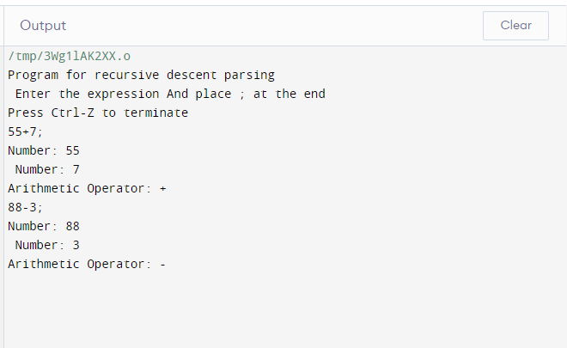

Program for recursive descent parsing

Enter the expression And place ; at the end

Press Ctrl-Z to terminate

55+7;

Number: 55

Number: 7

Arithmetic Operator: +

88-3;

Number: 88

Number: 3

Arithmetic Operator: -